**EECS 495 Biometrics**

**Assignment 1: Biometrics Systems Design and Evaluation**

|  |  |
| --- | --- |
| **Group Member:** | **Net ID:** |
| **Haikun Liu** | **hlg483** |
| **Ke Wang** | **kwp862** |

**1. Plot imposter and genuine distributions and corresponding ROC curve:**

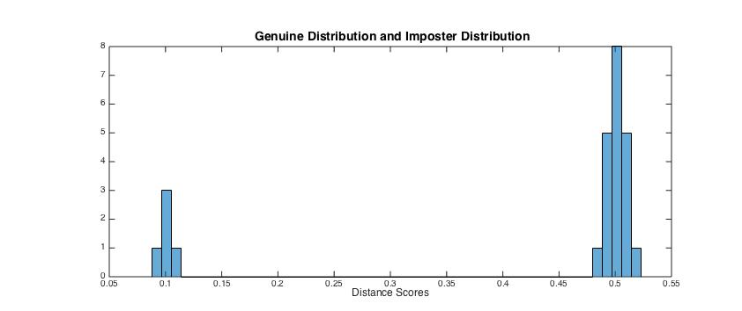Figure 1. Genuine distribution and imposter distribution of iris match system

According to the match scores and the equation 1.6 mentioned in Introduction to Biometrics, we got different points with different thresholds showed in the below table and then draw the ROC curve (Assuming a matching with its score equals to 0.5 is regarded as a true match).

|  |  |  |  |  |  |
| --- | --- | --- | --- | --- | --- |
| Threshold | FAR | FRR | Threshold | FAR | FRR |
| 0.09 | 0 | 0.8 | 0.324 | 0 | 0 |
| 0.108 | 0 | 0.2 | 0.342 | 0 | 0 |
| 0.126 | 0 | 0 | 0.360 | 0 | 0 |
| 0.144 | 0 | 0 | 0.378 | 0 | 0 |
| 0.162 | 0 | 0 | 0.396 | 0 | 0 |
| 0.180 | 0 | 0 | 0.414 | 0 | 0 |
| 0.198 | 0 | 0 | 0.432 | 0 | 0 |
| 0.216 | 0 | 0 | 0.450 | 0 | 0 |
| 0.234 | 0 | 0 | 0.468 | 0 | 0 |
| 0.252 | 0 | 0 | 0.486 | 0.05 | 0 |
| 0.270 | 0 | 0 | 0.504 | 0.70 | 0 |
| 0.288 | 0 | 0 | 0.522 | 1 | 0 |
| 0.306 | 0 | 0 |  |  |  |

Table 1. Threshold-FAR-FRR

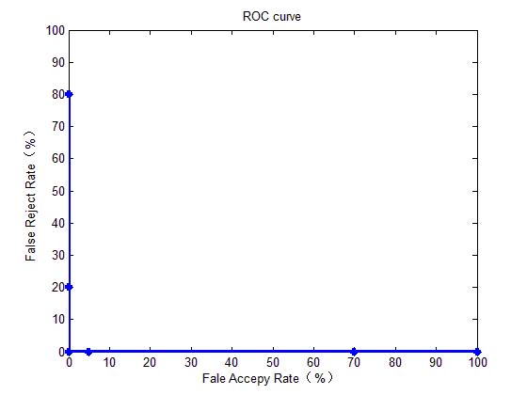

Figure 2. ROC curve of iris match system: False Accepy Rate vs. False Reject Rate

**2. Draw ROC curve of a “perfect” biometrics system. “Perfect” means that the system can achieve 100% TMR and 0% FNMR**

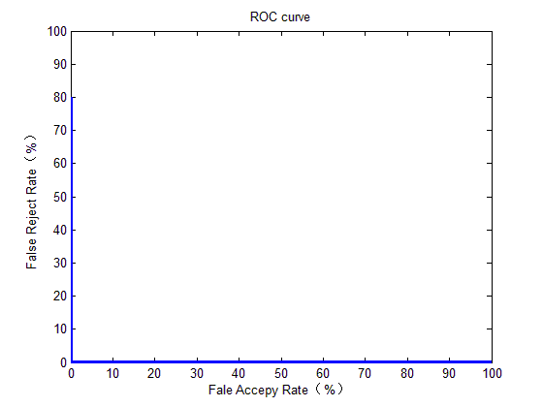

Figure 3. ROC curve of a "perfect” biometric system

If a system can achieve 100% True Match Rate and 0% False Non-match Rate (actually, TMR = 100% equals to FNMR = 0%), then there is no overlapping between its Genuine Distribution graph and Imposter Distribution graph. ROC curve reflects the relationship between False Positive Rate and True Positive Rate along with the change of threshold. It is used to evaluate the performance of the system as the threshold changed:

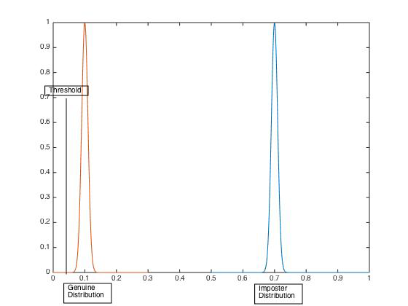

Figure 4. TPR = 0 and FPR = 0

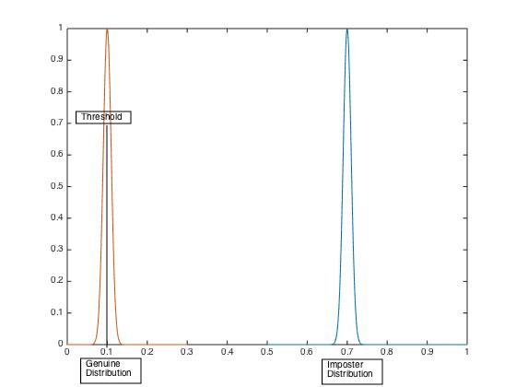

Figure 5. TPR increasing, FPR = 0

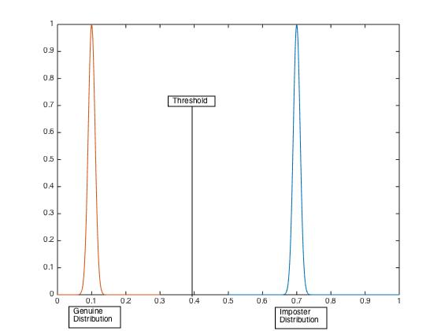

Figure 6. TPR = 1, FPR = 0

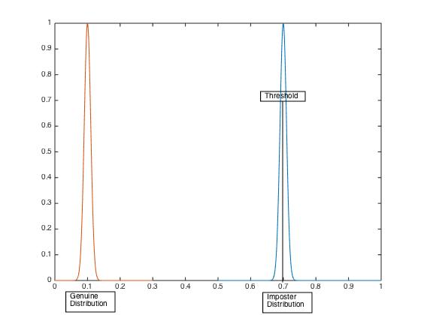

Figure 3. TRP = 1, FPR increasing

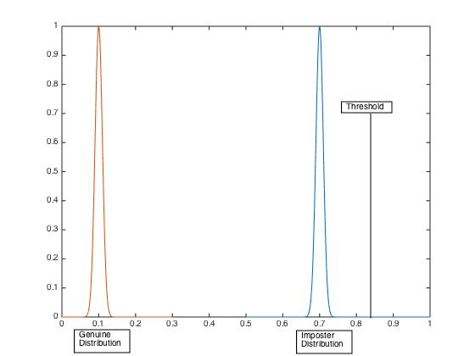

Figure 7. TRP = 1, FPR = 1

**3. Can we (NOT) estimate recognition error rates from verification error rates? Assuming (1) The identification system returns all the identities whose match score is above the threshold (2) The same threshold is used for both verification and identification scenarios.**

**If your answer is yes, how to derive FNR from FRR and FPR from FAR? If you answered no, please explain why? Which is challenging, verification or recognition, why?**

**Answer:**

Except for comparing different match scores against the threshold, identification also involves finding the top match among t identities. So there is some difference between identification error rates and verification rates.

However, under the assumptions mentioned in the question, we can actually estimate FNR and FPR from FMR and FNMR.

As with the same threshold used in both identification and verification, the probability that a query is falsely regarded as an invalid candidate in the database is the same as that in the verification system, which indicates FNR = FNMR. In some circumstances, FNR could be larger than FNMR. For example, when the quantity of the top matching set by the designer ***t*** is less than the number of possible matching whose matching scores are above the threshold ***N’***, then FNR can be larger than FNMR.

A false positive happens when the query is falsely regarded as a candidate of the biometric system. The probability that a false positive is counted equals to one minus the probability of no false matches occur for all ***N*** candidates in the database, which means FPR = 1 - (1 - FMR)^***N***. Note that, FPR = FMR happens when ***N*** = 1; and FPR increases as database size N becomes larger.

When implementing the same threshold, the identification system can achieve FNR = FNMR with ***t***=***N’*** and FNR > FNMR with ***t***<***N’***. For FPR, ***N*** is a large number so it makes FPR>FMR. According the relationship FNR ≥ FNMR and FPR>FMR, we draw the conclusion the difficulties of designing an identification system are more than that of a verification system.